**Table of Contents**

**1. SRS**

1.1. Introduction 3

1.1.1 Purpose 3

1.1.2 Scope 3

1.1.3 Definitions, Acronyms and Abbreviations 3

1.1.4 Overview 3

1.2. Positioning 4

1.2.1 Business Opportunity 4

1.2.2 Problem Statement 4

1.2.3 Product Position Statement 4

1.3. Stakeholder and User Descriptions 5

1.3.1 Market Demographics 5

1.3.2 Stakeholder Summary 5

1.3.3 User environment 5

1.3.4 Key Stakeholder / User Needs 5

1.4. Product Overview 6

1.4.1 Product Perspective 6

1.4.2 Summary of Capabilities 6

1.4.3 Assumptions and Dependencies 6

1.5. Product Features 7

1.5.1 Functional Requirements 7

1.5.2 Non-Functional Requirements 8

1.6. Constraints 9

1.7. Quality Ranges 9

1.8. Other Product Requirements 10

1.8.1 System Requirements 10

1.8.2 Environmental Requirements 10

1.9. Documentation Requirements 11

1.9.1 User Manual 11

1.9.2 Online Help 11

1.9.3 Installation Guides, Configuration, Read Me File 11

1.9.4 Labeling and Packaging 11

1.10. Appendix 1 - Feature Attributes 12

1.10.1 Status 12

1.10.2 Effort 12

1.10.3 Risk 12

1.10.4 Stability 12

1.10.5 Target Release 12

1.10.6 Assigned To 13

1.10.7 Reason 13

**2. UML Diagrams**

2.1 Use Case Diagram 14

2.2 Activity Diagram 15

2.3 Sequence Diagram 16

2.4 Class Diagram 16

2.5 State Diagram 17

**3. Wireframe Screens of the project**

3.1 User Side 18

3.2 Admin Side 22

**4. Code Screenshots** 23

**5. Website Screenshots** 26

**Vision**

# **1.1 Introduction**

The main objective of this document is to collect the needs of users and accordingly analyze the features of the Complaint Management System. It focuses on capabilities needed by accountants, employees, management team, account section, and directors, and also focuses on the Reports section. The system is built so that it saves time by storing the information in the database reducing the use of paperwork. The system helps the users to directly register their complaints through the use of a Complaint management website or application.

## **1.1.1 Purpose**

Main purpose of this system is to provide a product that is far better than the current complaint system. It helps management by easy maintenance of all information as we can store all the information into the database instead of storing it in the papers as was done before. This system is easy to use as before complaints were taken at some place where users have to go to register their complaints. So by using this system they can directly register their complaint by using the respective app or website.

## **1.1.2 Scope**

Complaint management system is developed for a society which has keen interest in getting feedback from the members of the society. It provides a mechanism to get complaints / feedback from the members residing in the society by avoiding the paperwork and storing the data dynamically to databases so as a result this reduces the time of fetching the information from paperwork. The system focuses on managing customers' complaints and passes that to the particular department.

## **1.1.3** **Definitions, Acronyms and Abbreviations**

IEEE The Institute of Electrical and Electronics Engineers, Inc.

CMS Complaint Management System

CMSS Complaint Management System Software

SRS Software Requirement Specification

## **1.1.4** **Overview**

## This document has been prepared in accordance with the IEEE Std. 830, 1998. This document covers requirements, technical information and user manual of the Complaint Management System. It provides the information of Product perspective, Product functions, User characteristics, Constraints, Assumptions and dependencies and specific requirements.

# **1.2 Positioning**

## **1.2.1 Business Opportunity**

The business opportunity for this product is huge in societies where there is feedback and complaints are accepted from the members of the society.

## **1.2.2 Problem Statement**

Regular Complaint management system has lots of drawbacks and problems. For instance, if it is needed to find out a complaint of a customer, then it becomes quite a time consuming job to find out the paper from the physical paper file. If a user files a complaint on paper, the user has to wait a little longer for a reply from the particular authority. And also maintaining the data in the papers is very difficult. So this software will help to store data in the database and can be easily accessed within seconds. Another problem is that to file a complaint within the society members have to go to an authorised person in order to file their respective complaint. So such problems can be solved by providing an online complaint management system.

## **1.2.3 Product Position Statement**

The complaint management system is stand-alone software that manages complaints of the societies. The key points of the Complaint management system are the Complaint registering page and if the complaint is not answered timely, users can again raise a ticket in which higher authority will be informed and action will be taken based on the complaint number and that particular department will be consulted regarding the issue. Another function is to do the analysis for common problems and to provide appropriate solutions.

# **1.3 Stakeholder and User Descriptions**

## **1.3.1 Market Demographics**

Our primary focus is on the users of our products, which are the members of the society which uses any complaint management system software as a platform to take complaints from users. We can say that it can be for the age group like 15-65. Considering the complaints the society committee members can improve their society facilities which would be beneficial for the members of the society.

## **1.3.2 Stakeholder Summary**

| **CEO/Product Owner** | CEO/Product Owner are the ones which are the main stakeholders of the company and they think for the betterment of the company or the product by taking best suitable decisions for the benefit of the users as well as company. Product owners keep keen interest in the process of work and designing and also in engineering to make sure that the system requirements are met according to the needs of the users. He will also make sure that the technology used is the latest one and the flow of product development and its process is also good. |
| --- | --- |
| **Category of Users** | The users are the ones who will use the system of Online complaint management system. In the complaint management system the main users are members of the society. |
| **Admin** | The admin user of the complaint management system can manage the user data and manage the solution of the complaints of the users. At the admin side of the complaint management system admin can see how many complaints are registered and how many users are using the system. The list of departments can also be handled from the admin side. So we can say that admin is also the main stakeholder of the complaint management system. |

## **1.3.3 User Environment**

The first time the user uses the complaint management system, they will need to register themselves by filling up a sign-up form.Then they will be asked to login by entering to the login page. After logging in to our website User will be able to register its complaint about the particular department. While filing a complaint, users will be asked for the department they are willing to complain to. Then they can select the topic of complaint then the user can file their complaint over there by filling the form. Users can check their old complaints and responses at the dashboard.

## **1.3.4 Key Stakeholder / User Needs**

Nowadays there are too many companies providing too many services but not everyone gets the perfect use of the service as they might have a slight issue / problem with the society's particular service. Then the user will want to complain about that particular problem. The user will also want a seamless system where they can complain about their problem easily. The societies will also want this type of system to improve themselves and resolve their members' problems.

# **1.4 Product Overview**

## **1.4.1 Product Perspective**

The complaint management system is stand-alone software that manages complaints of the society. When any user files a complaint about a particular problem the complaint first goes to the admin department and then goes to the particular department.If they can resolve their complaint over the message they will resolve the complaints over the complaint system by replying to that complaint.

## **1.4.2 Summary of Capabilities**

* Users can complain about any problem any time.
* User will have tracks of their past complaints in the dashboard

## **1.4.3 Assumptions and Dependencies**

The complaint management system is used by the members of the society who can file their complaint by using the complaint management system. The user must understand the system properly in order to file a complaint. They must know the department of their complaint for filing the complaint properly.

# **1.5 Product Features**

## **1.5.1 Functional Requirements:**

1. **Functions:** User Login

**User:** Any

**Input:** Username and Password.

**Output:** If the user name or password is incorrect an error generates. If the user name and password are correct then the user is able to access the functionalities according to their access level.

**Results:** The user is granted access to functionality according to type of user.

1. **Functions:** Change Password

**User:** Any

**Input:** Old password, new password and re-enter new password.

**Output:** If old password is incorrect or new password and re-enter new password doesn’t match or new password doesn’t follow password protocol an error generates. If all requirements for a full fill password are set to a new password.

**Results:** Old password replaced with new password. So, the user has to use a changed password for login next time.

1. **Functions:** Register a User

**User:** Any

**Input:** User’s name, Phone number, Email, Password, Re-type Password.

**Output:** If inserted information is valid then user registers to system else generates errors.

**Results:** Registered user reflects in other modules related to his/her.

1. **Functions:** Raise a complaint

**User:** User

**Input:** Username, UID, Complaint category, Date, Complaint title, Complaint Description

**Output:** If inserted information is valid then a complaint is submitted to the system else it generates errors.

**Results:** This information is reflected in the complaints module.

1. **Functions:** User dashboard

**User:** User

**Output:** User can see their previous complaints and its responses

1. **Functions:** Admin dashboard

**User:** Admin

**Output:** Admin can see all complaints and its responses

## **1.5.2 Non Functional Requirements**

**1.5.2.1 Security**

Priority: High

* The profile details of the users are kept secure in the database and the databases are not allowed to to viewed to everyone
* The password which the user entered is not stored in the database.
* The Admin modules are kept different from the main modules and its accessabilities are given to very limited developers

**1.5.2.2 Reliability**

Priority: High

* Fault tolerance - The data are stored in multiple places to protect the data in case of any loss of any data from a particular fromparticular from a particular database. So there is no fear of losing the user data.
* Non-deficiency – degree to which SW does not contain undetected defects

**1.5.2.3 Maintainability**

Priority: High

* Finding and fixing the bugs if any
* According to the bugs or any default in functionality there patch update will be given
* Change in hardware for improvements
* Addition of new functionality and new modules according to the requirements
* After the changes updating the documentation and again maintaining it

**1.5.2.4 Portability**

Priority: Medium

* Hardware Independence – Software of this system does not relay on any specific hardware requirements
* Software Independence – Software of this system does not relay on any specific software environment

**1.5.2.5 Reusability**

Priority: Medium

* Generality – This system can be reuse across another application

# **1.6 Constraints**

* Live tracking of the complaint is not possible here as once the complaint is reached to particular department and they start to work on the problem user can not see the progress regarding their complain
* As a disadvantage due to the online source of complaining there is no source of interacting with the department handler so that the complaint can be expressed properly.

# **1.7 Quality Ranges**

* This system is so robust that with use of this system users can fill up complaints at any time from anywhere and as many as they want. There are lesser chances of system faults.
* There is a security feature about the user that the name of the complainant does not appear to the main authority.

# **1.8 Other Product Requirements**

## **1.8.1 System Requirements**

**Minimum Hardware Requirements :**

* Laptop / Desktop
* Processor - 1GHz or Above
* Ram - 2GB or Above
* Free Disk Space - 30GB or Above
* Internet Connection

**Minimum Software Requirements :**

* Eclipse IDE 2021-12 4.0 or higher
* Apache Tomcat Server v10.0 or higher
* JDK 12.0 or higher
* JavaSE-14 or higher
* JRE 6.0.1
* MySQL Workbench 8.0 or higher
* Bootstrap
* MDBootstrap

## **1.8.2 Environmental Requirements**

A periodic backup of the database is suggested so in case one of it crashes or any data loss happens from one database we can have backup in another so there can be no reliability on one database.

# **1.9 Documentation Requirements**

## **1.9.1 User Manual**

User Manual Contents:

1. How to use the system
2. How to use each page with screenshots
3. How to use backup and restoration (in case of database crash and recovery)

## **1.9.2 Online Help**

N/A

## **1.9.3 Installation Guides, Configuration, Read Me File**

As this is a web application there is no installation guide required and also there is no readme file. The interface of the web application is very easy to use and configurations are mentioned above.

## **1.9.4 Labeling and Packaging**

N/A

# **1.10 Appendix 1 - Feature Attributes**

## **1.10.1 Status**

| **Proposed** | Live track of complaint, user verification |
| --- | --- |
| **Approved** | User registration,user login,forget password, raise a complaint, \User Dashboard |
| **Incorporated** | User registration,user login,forget password, raise a complaint, live track of complaint, user verification,User Dashboard |

## **1.10.2 Effort**

The development of the project has been done by the joint effort of all the team members Jinay Shah and Purav Shah. Without the team it would not be possible to complete the project. The work done together with equal efforts of each one for example system analysis, document analysis, use case study, software coding, database designing, software testing etc.

## **1.10.3 Risk**

* cost is also increased as increased hardware or/and software cost is increased due to licence version.
* It may take time to complete a project. So delay will be generated to release a software
* Some bugs will not be solved

## **1.10.4 Stability**

In the process of development of a project if the client asks about the change in information or any addition in the project the changes may be done accordingly but not in between the ongoing sprints but after the work with higher priority is completed.

## **1.10.5 Target Release**

## The final release will allow users to signup, login and raise complaints. It will allow the users to signup,login in order to raise a complaint about a particular department. Users will get the response from the responsible department over here only. Users can check their previous complaints and their responses in the dashboard area. The Complaint management system’s final launch will be approximately after 4 months of developing stage and it will get updated further by regular updates.

## **1.10.6 Assigned To**

| **Project Management Team** | This team will ensure proper flow of the project based on time and work |
| --- | --- |
| **Research & Analytics Team** | This team will do the user research and requirement analysis |
| **Frontend Designer Team** | They will design the UI/UX of project for better experience |
| **Frontend Developer Team** | They will develop the frontend based on the designs of the Frontend Designer Team. |
| **Backend Designer Team** | They will construct & design the system architecture and database designs |
| **Backend Developer Team** | They will develop the backend on the basis of the system requirements given by the Backend Designer Team |
| **Software Testing Team** | They will ensure the testing of the product prior to launching. They will make sure that no potential bugs are present |
| **DevOps Team** | They will deploy the final product to the servers and maintain the integrity of the product. |

## **1.10.7 Reason**

The main reason for this document is to understand the needs of clients and tools and technology and basic understanding of the project. This document will give the flow of how the project will be implemented, how the project will be and what is the main purpose of the project.

**2. UML Diagrams:**

**2.1 Use Case Diagram**

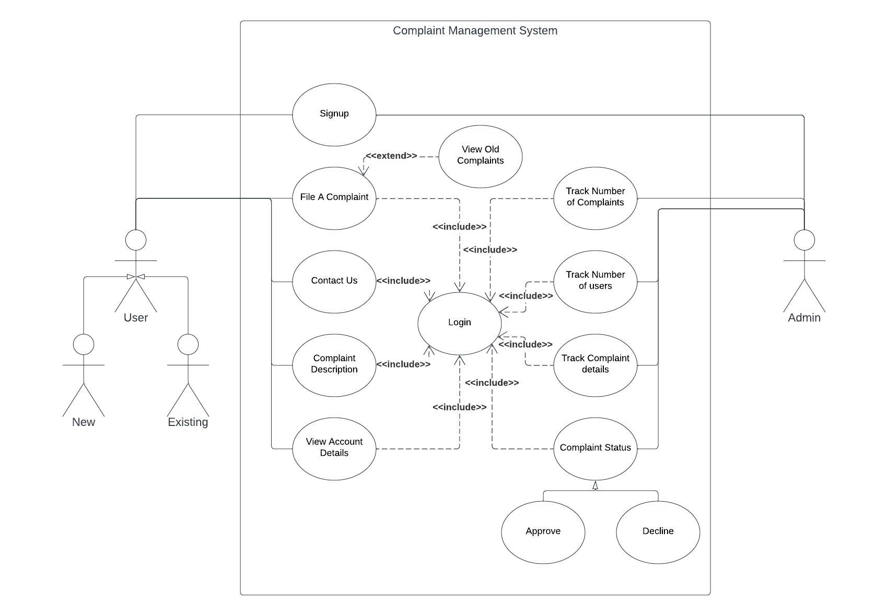

**2.2 Activity Diagram**

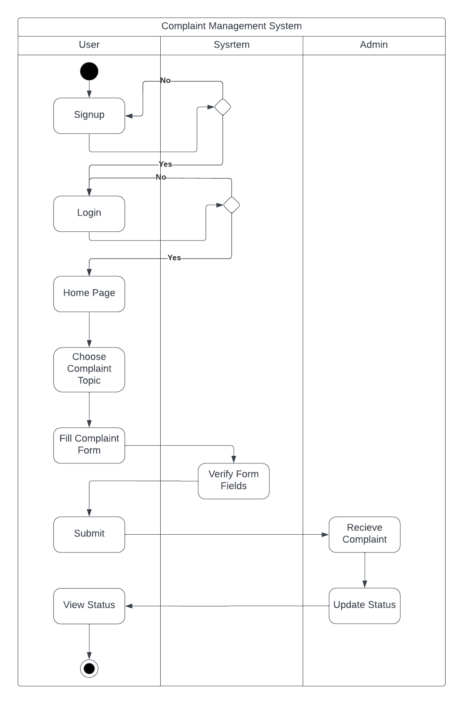

**2.3 Sequence Diagram**

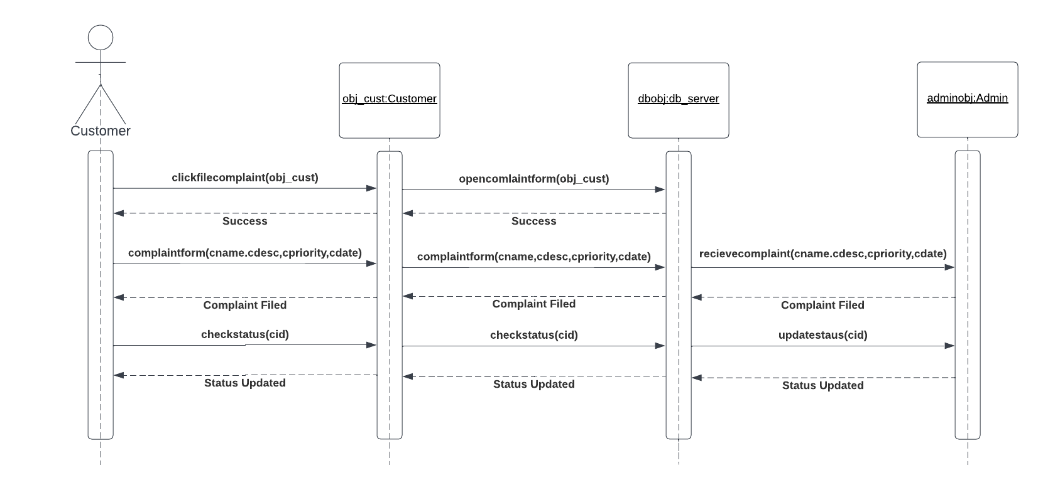

**2.4 Class Diagram**

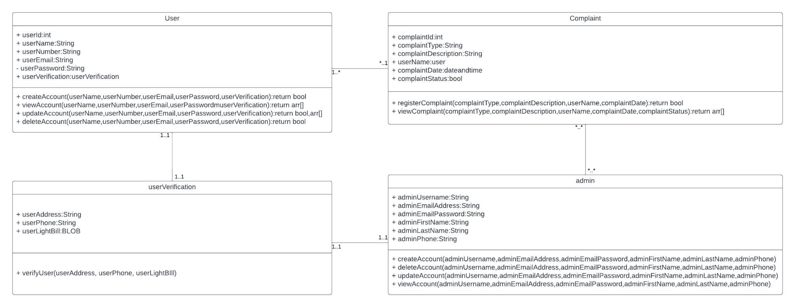

**2.5 State Diagram**

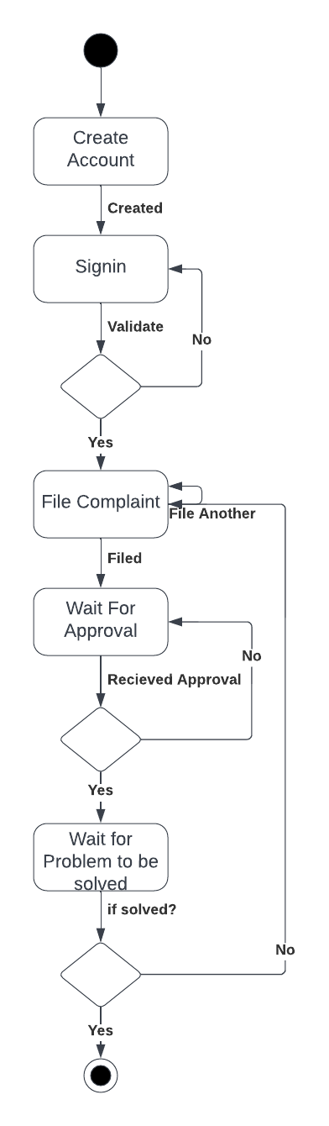

**3. Wireframe Screens of the project**

**3.1 User Side:**

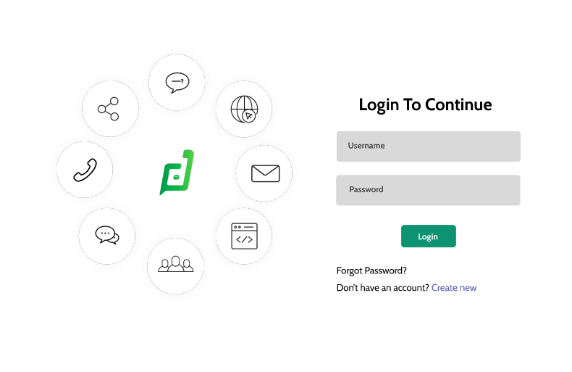

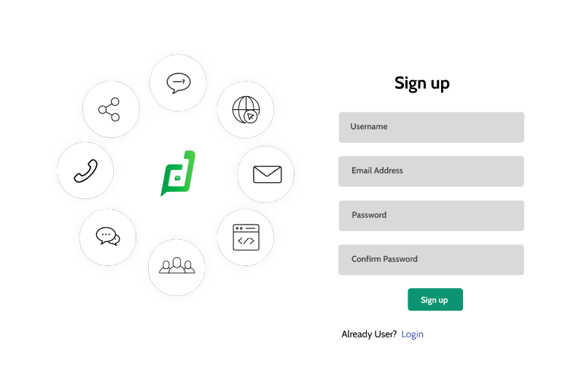

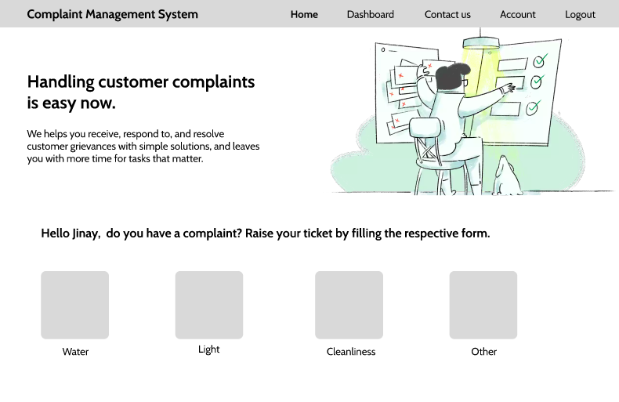

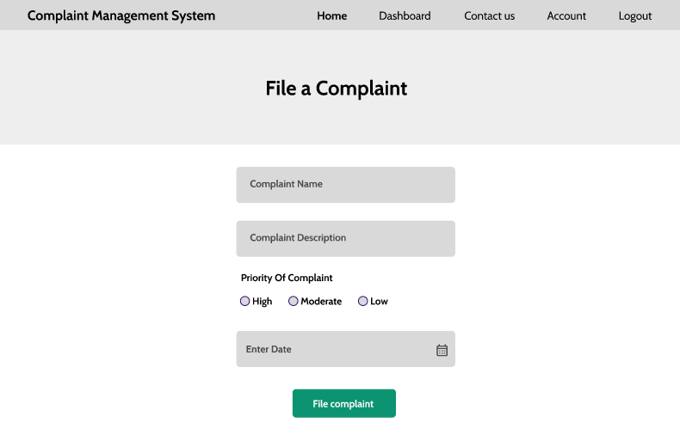

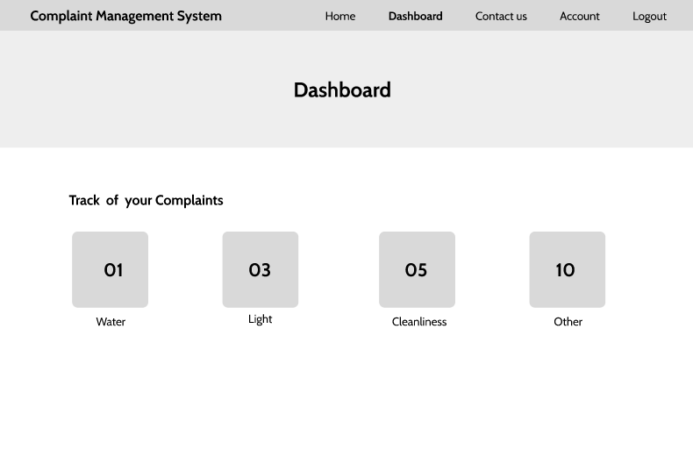

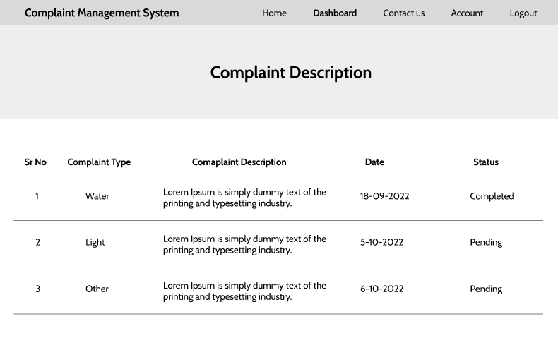

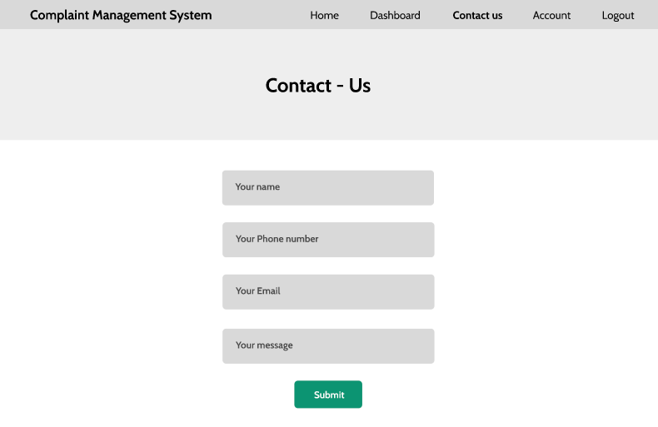

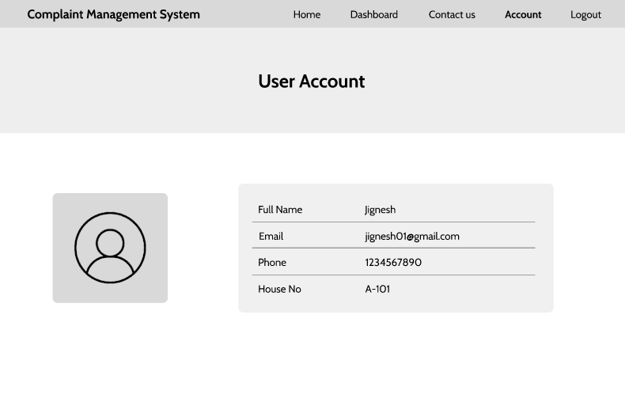

**3.2 Admin Side:**

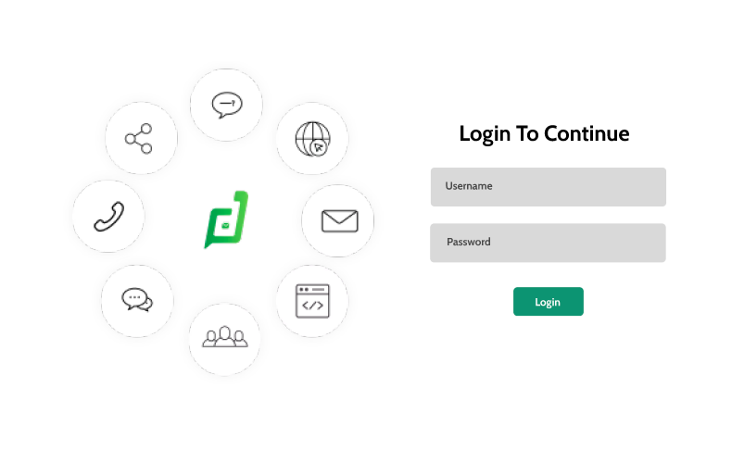

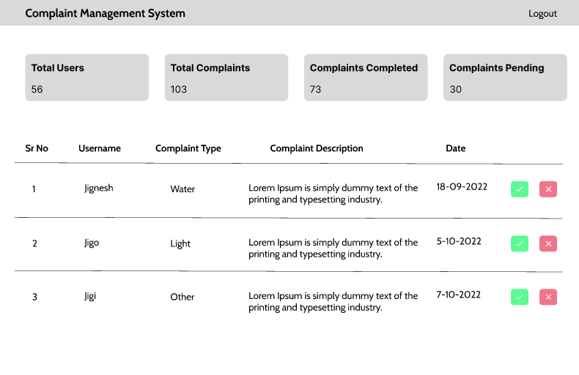

**4. Code Screenshots**

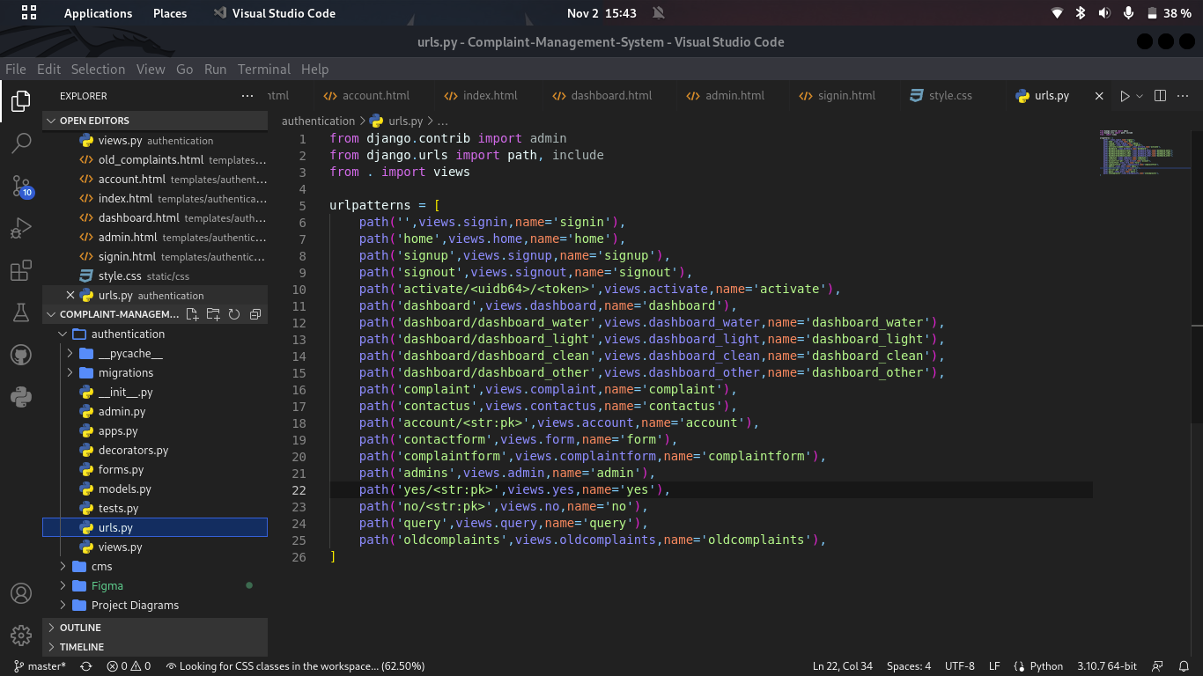

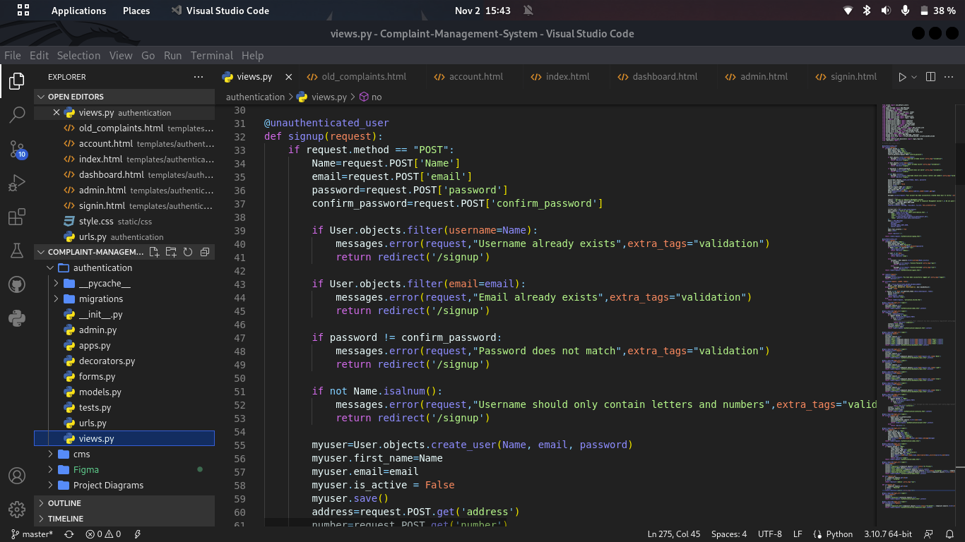

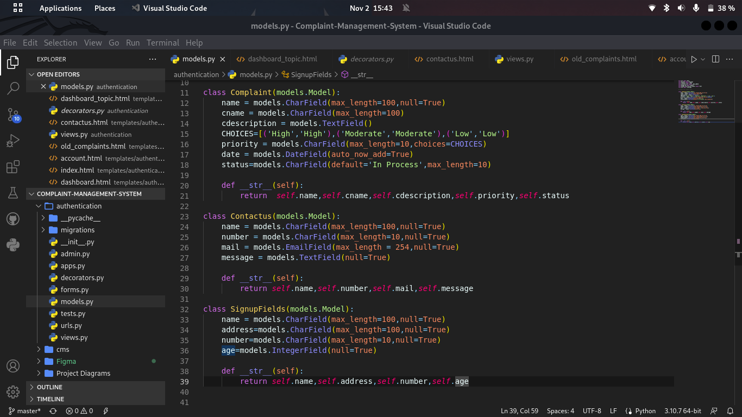

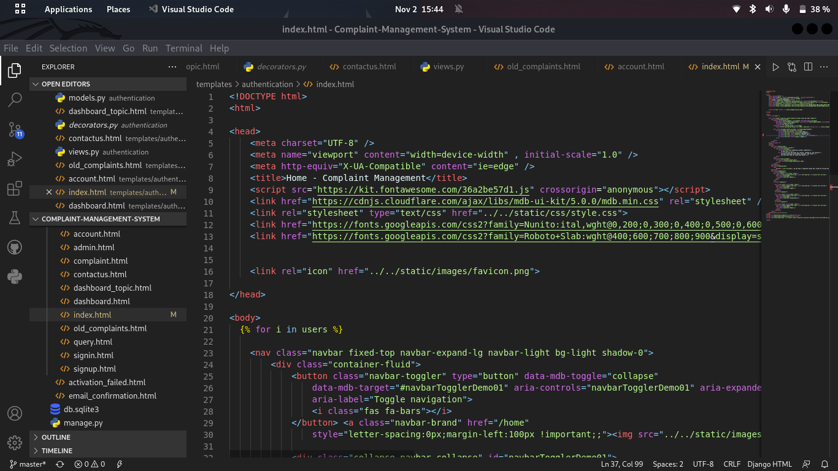

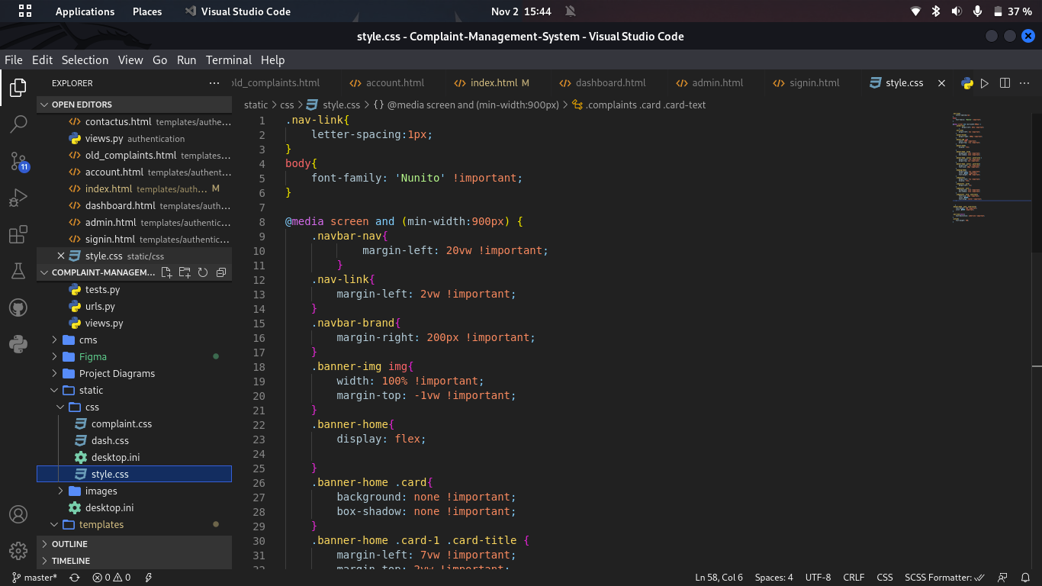

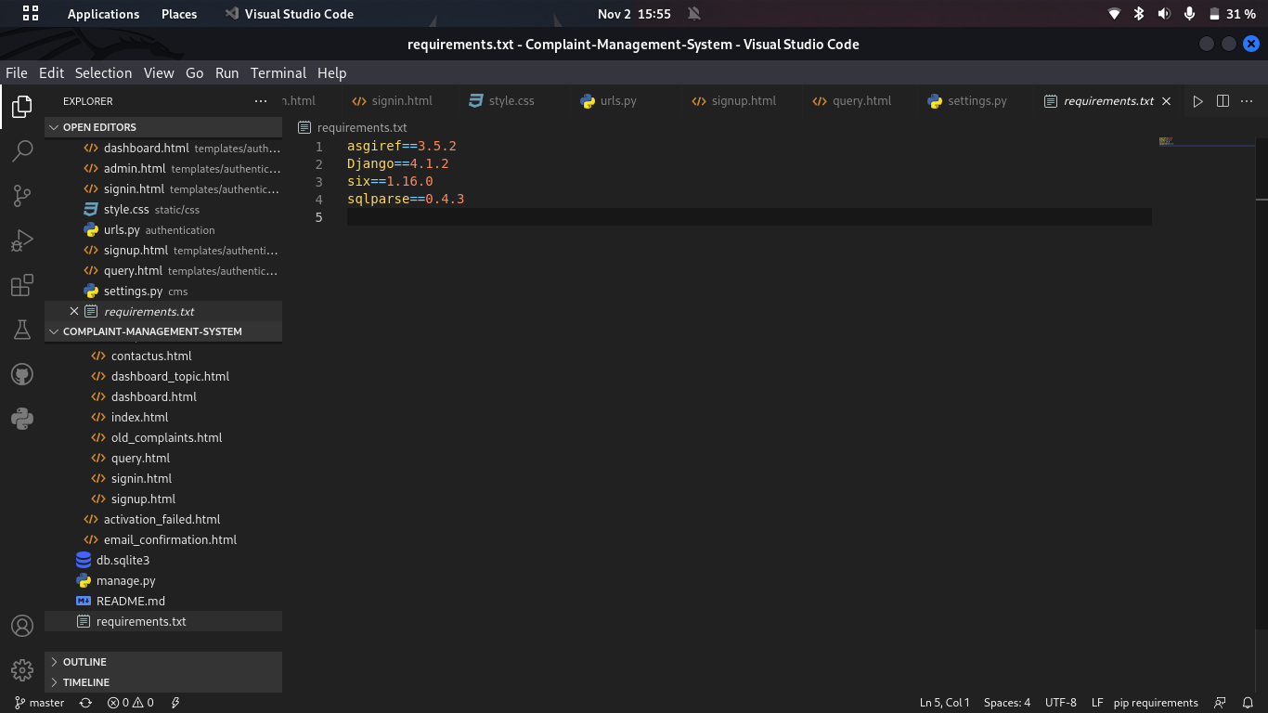

**5. Website Screenshots(User Side)**

Signup Page

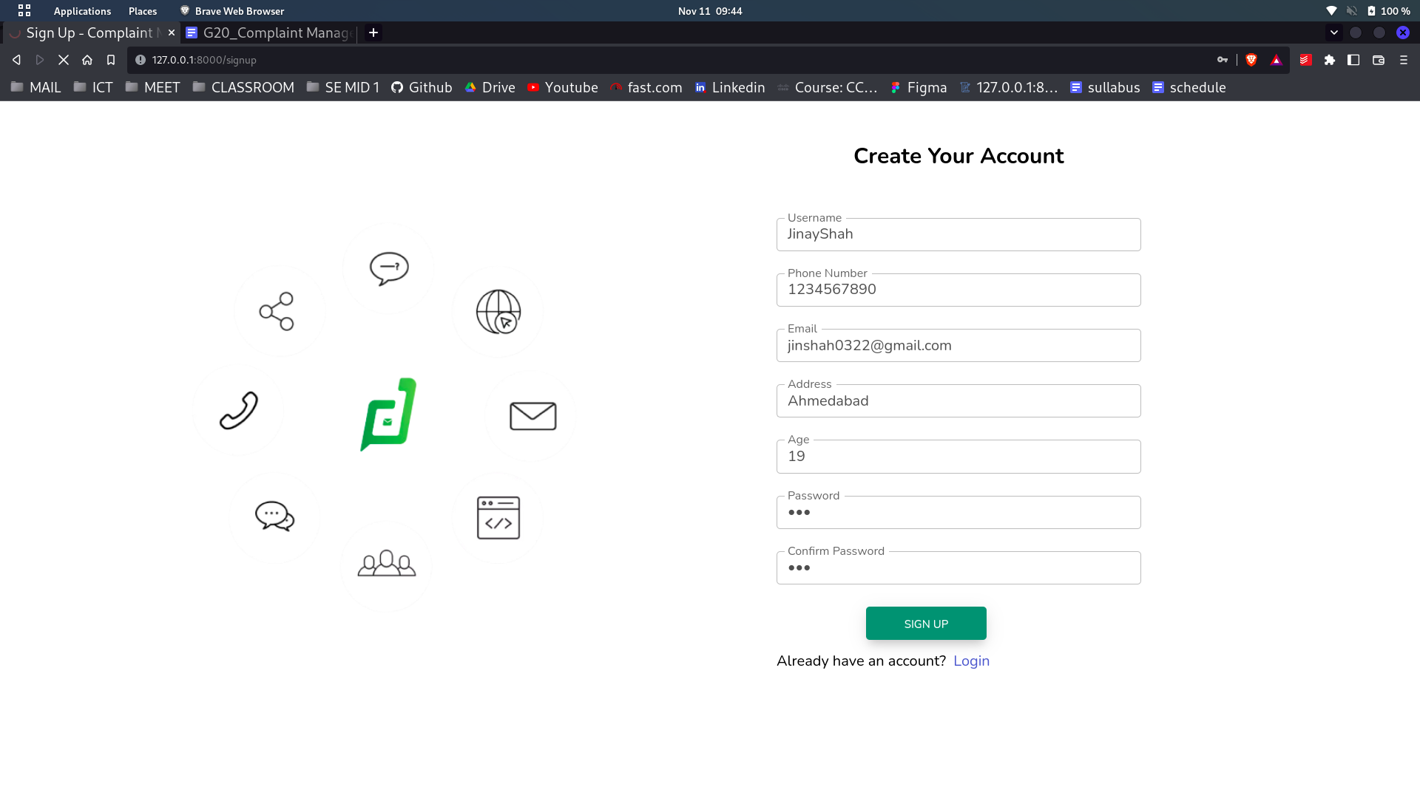

Email Verification

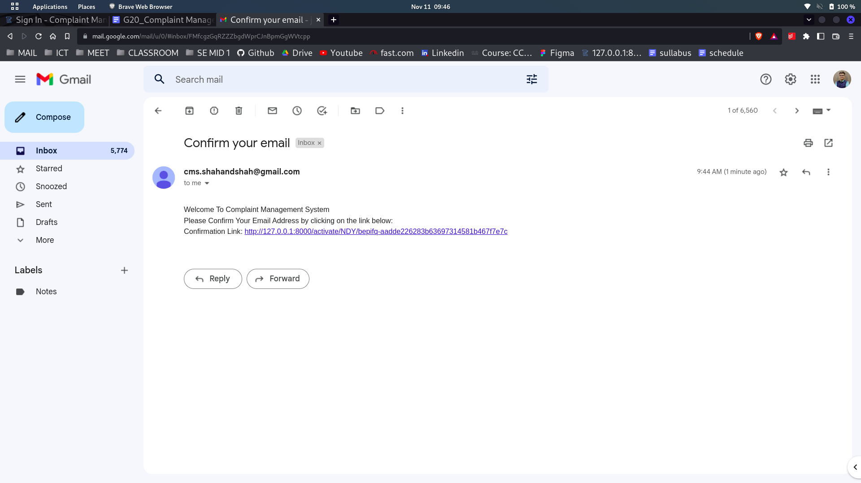

Login Page

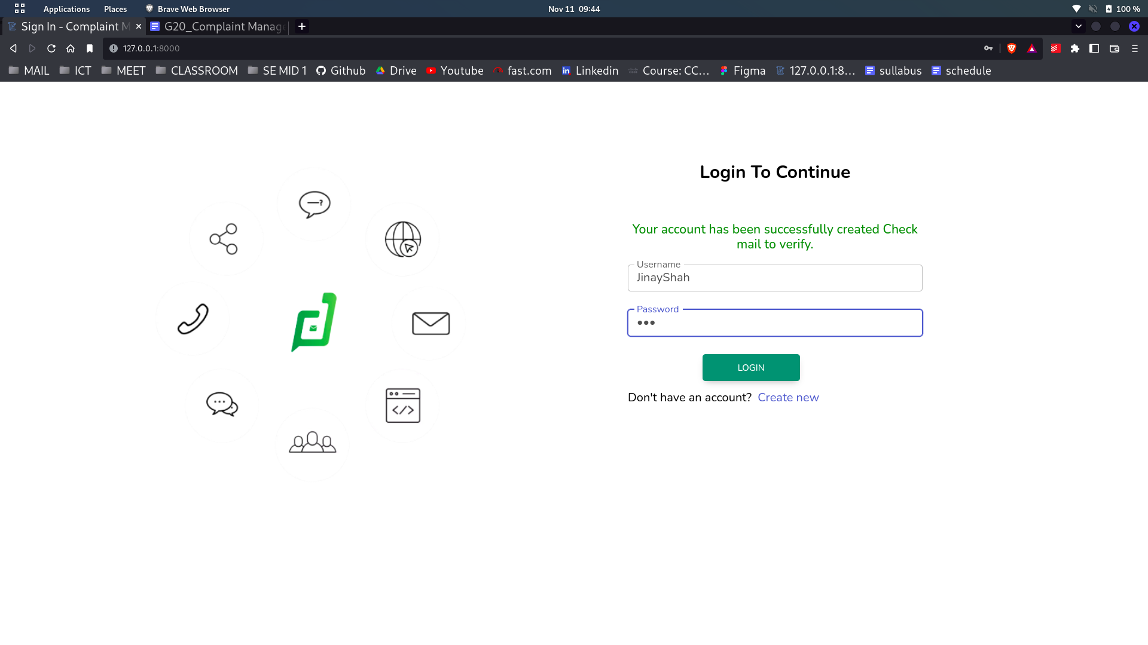

Home Page

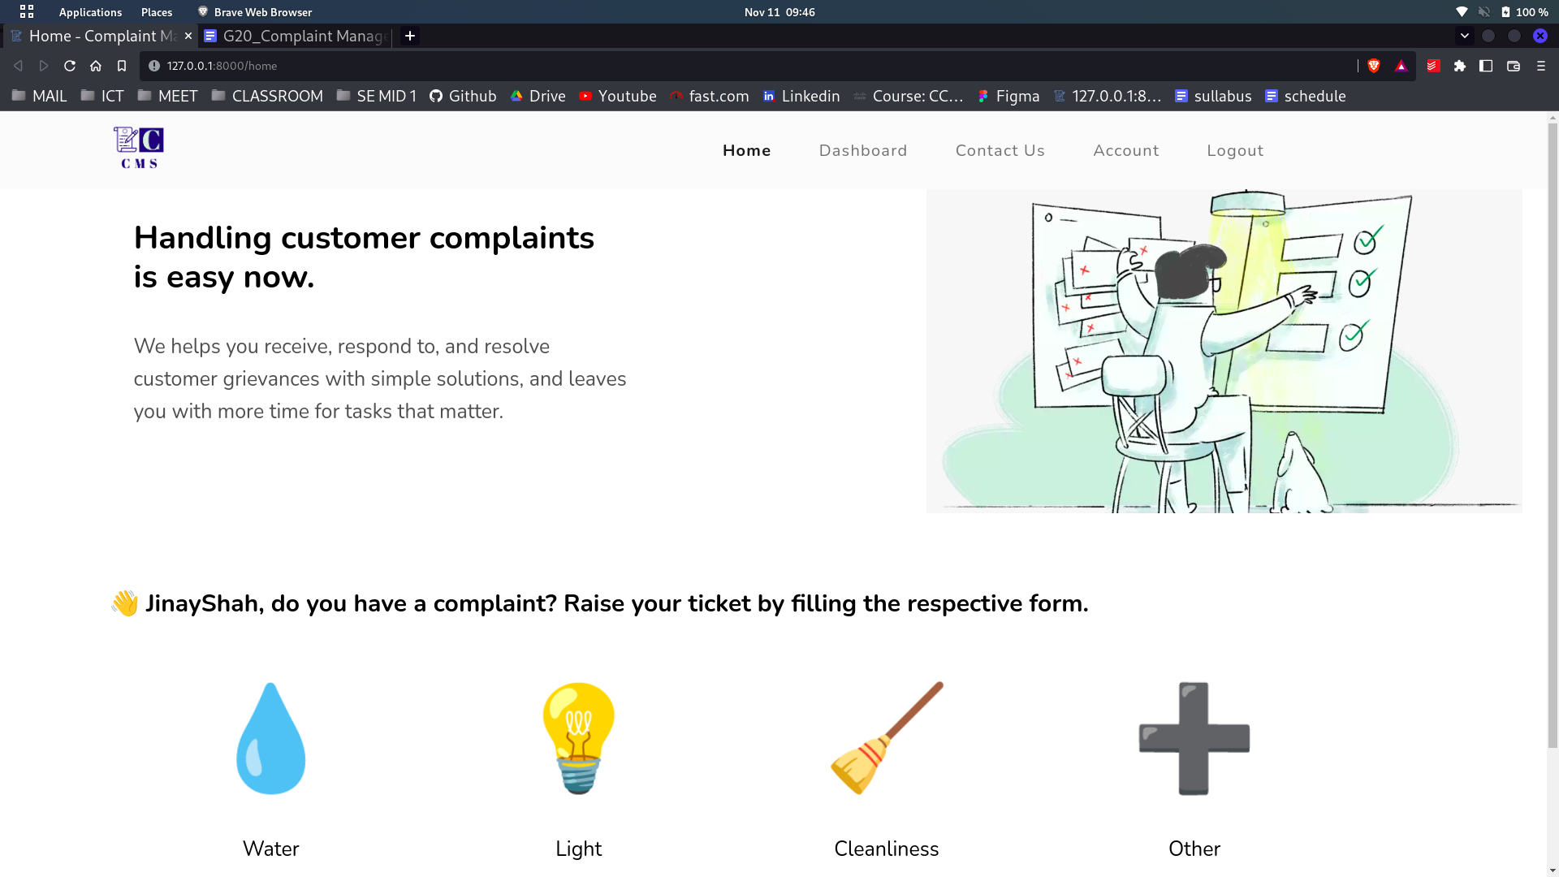

Contact us page

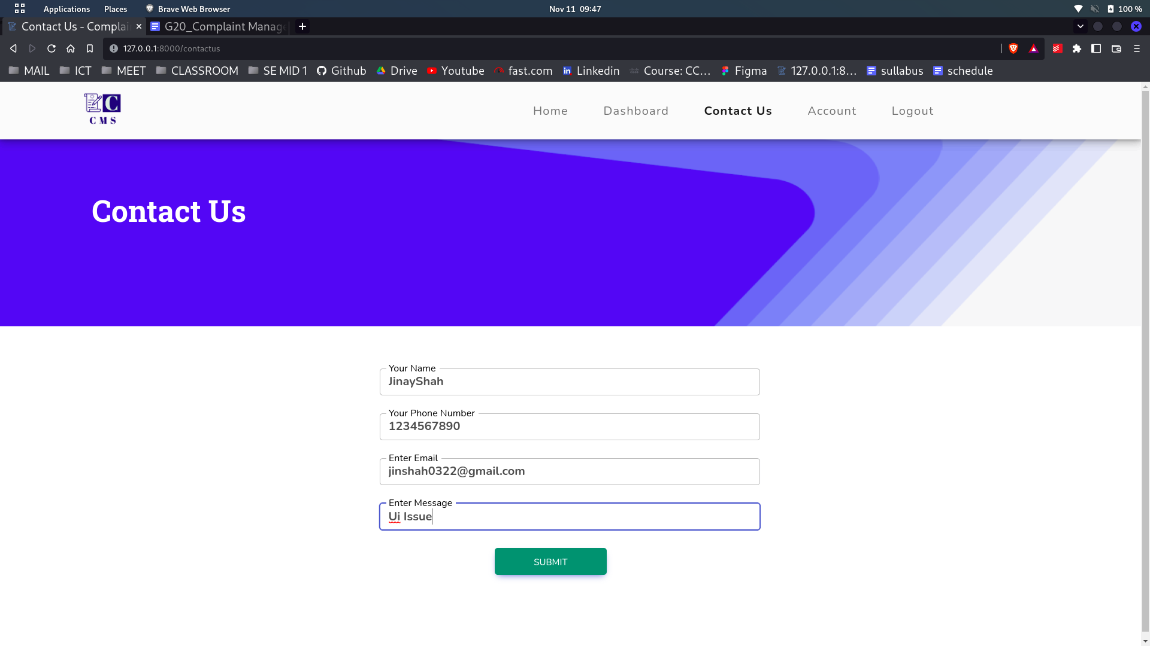

User Account page

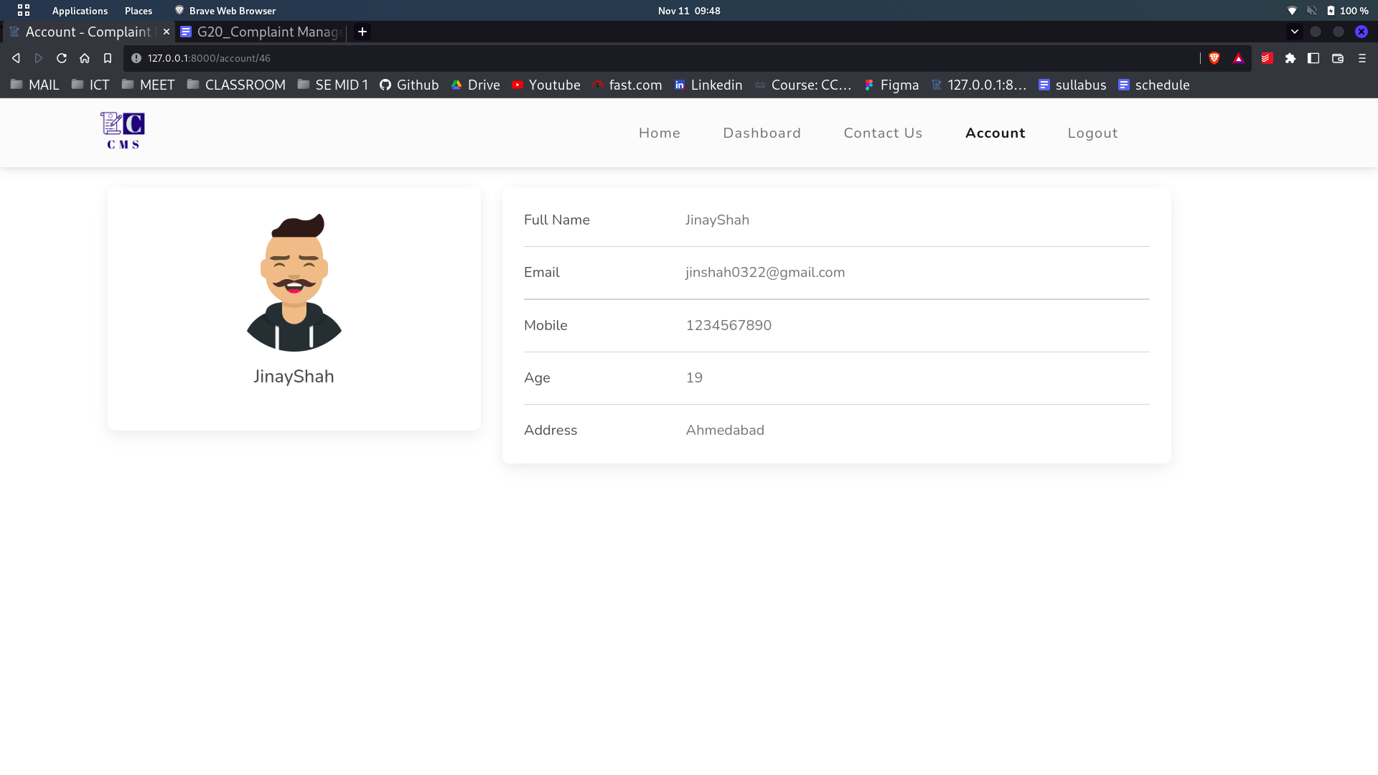

Complaint Page

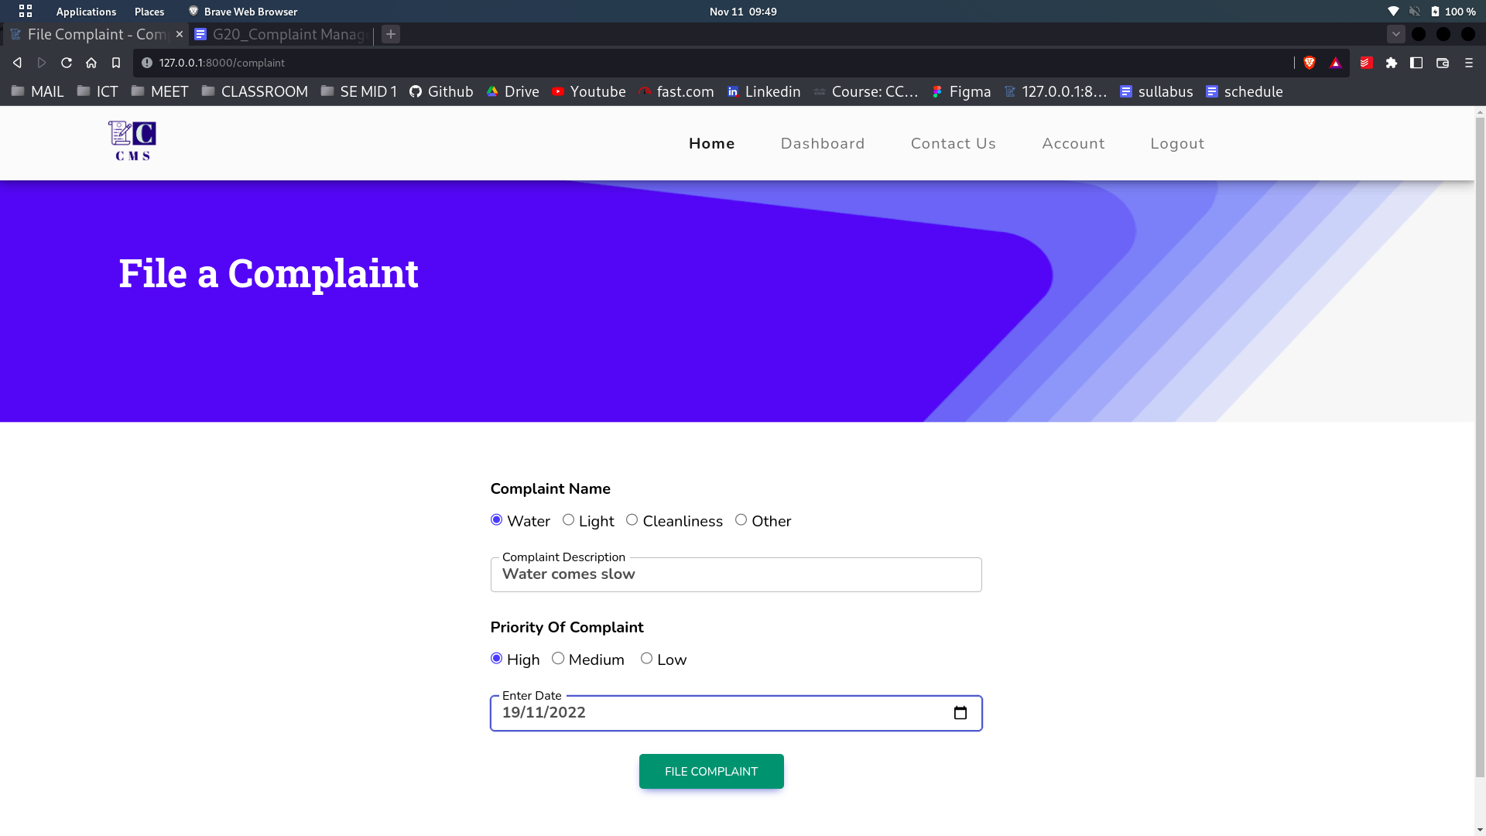

User complaint dashboard

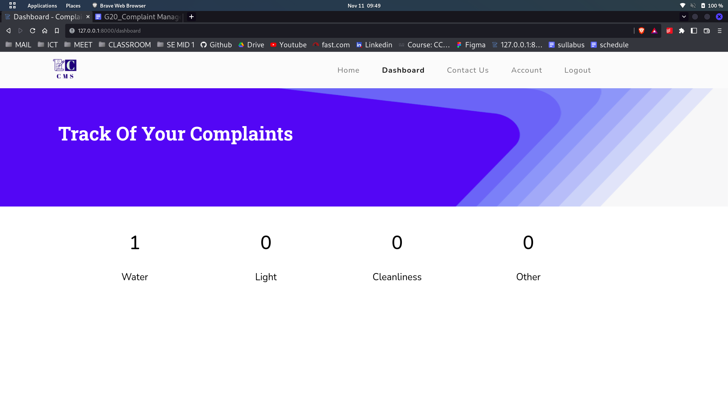

**Admin**

dashboard page

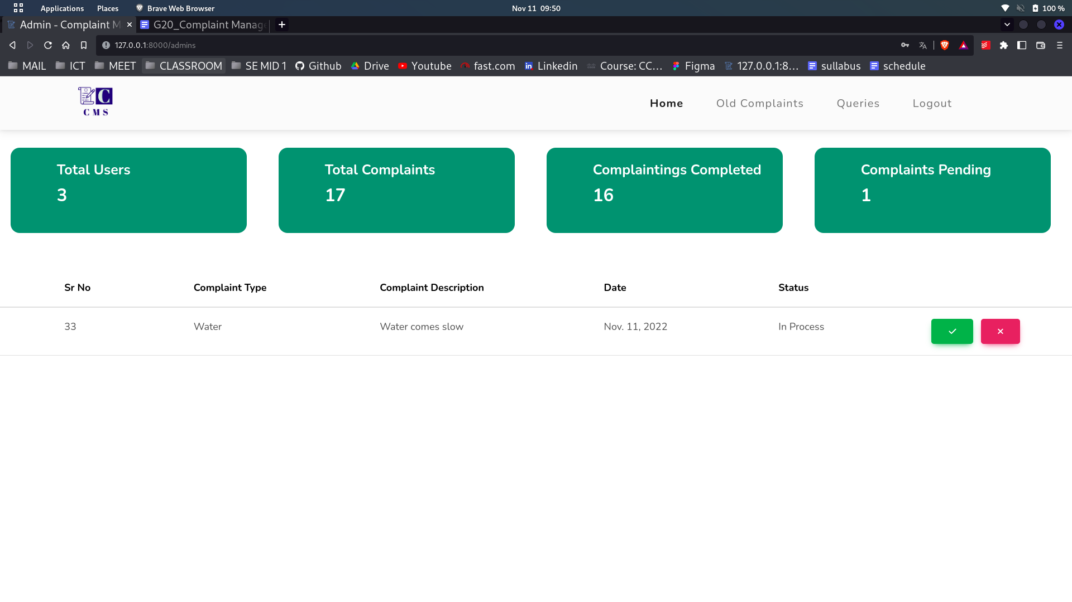

Old complaints page

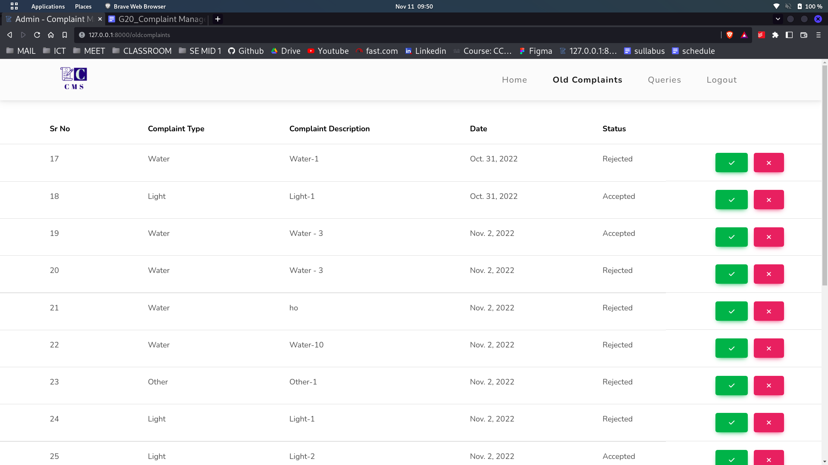

Contact us query page

